

A MINI PROJECT REPORT

On

MUSIC PLAYER USING PYTHON

Submitted in partial fulfillment of the requirement of University of Mumbai for the Course

**In**

# Computer Engineering (IV SEM)

Submitted By

**Soumyojyoti Dutta**

**Moksha Shinde**

**Vedang Gore**

Subject In charge

**Subject In charge Name**

(Merlin Priya Jacob)



**CERTIFICATE**

This is to certify that the requirements for the project report entitled ‘**Project Title**’ have been successfully completed by the following students:

|  |  |
| --- | --- |
| **Name** | **Moodle Id** |
| Soumyojyoti Dutta | 19102014 |
| Moksha Shinde | 19102064 |
| Vedang Gore | 19102065 |

In partial fulfilment of the course Python Programming (COMPS 403) in Sem: IV of Mumbai University in the Department of Mechanical Engineering during academic year 2020-2021.

Sub-in-Charge

# 

# PROJECT APPROVAL

The project entitled ‘**Music Player** by **Soumyojyoti Dutta, Moksha Shinde, and Vedang Gore** are approved for the course of Python Programming (COMPS 403) in Sem: IV of Mumbai University in the Department of Mechanical Engineering.

Subject-in-Charge

Date:

Place: Thane

**Table of Contents**

|  |  |  |
| --- | --- | --- |
| **Sr**. **No.** | **Topic** | **Page No.** |
| 1. | Abstract(150-200 words) | 5 |
| 2. | Problem Definition | 6 |
| 3. | Introduction | 7 |
| 4. | Description of the modules used | 8 |
| 5. | Implementation details with screen-shots (stepwise) | 9 |
| 6. | Conclusion and Future Scope | 12 |
| 7. | References | 13 |
| 8. | Acknowledgement | 14 |

**Abstract**

Music player using python is a simple application, modified according to daily needs. Audio is an important source of communication and is as important as text in today’s time. We know that the audio files are digital files. Therefore, there is a need of a tool to run the digital files or in other words, play the files. Thus, we need a music player, which has the capabilities of playing a song, create and display a playlist, pause and resume a long and change the song, that is, play the previous or next song.

Music player is a device using to play MP3s and other digital audio files. We can build this by ourselves without having to download and install premium music players. This program will allow you to play songs and all MP3 files on your desktop or laptops. MP3 player using Python is a basic programming application built using the programming language Python. It is a GUI program built by the means of Python libraries Tkinter, Pygame. This application can be further modified as it develops, adding new features that will make the experience of listening to music even more enjoyable and satisfactory.

**Problem Definition**

* 1. To build an MP3 player using Python programming language to be able to play and listen to songs, MP3 files and other digital audio files.
  2. Determine the functionalities of the MP3 player.
  3. The player should be having a simple and easy to use GUI with options for various functions, display screen to display the entire playlist and buttons to shut down the player.
  4. The player should be able to play any song.
  5. The player should allow the user to browse through the contents of the computer drive to choose song/s to be played or queued.
  6. It should provide the user with option to pause or resume the song.
  7. The user should be able to play the previous or the next song in the playlist.

**Introduction**

We need an application that will allow us to play or listen to digital audio files. The music player GUI program application attempts to emulate the physical MP3 Player. This program will allow you to play songs, music, and all MP3 files on your desktop or laptops.

The main objective of this project is to allow users to play MP3 and digital audio files. To be engaging for users, the application has to have a simple but user friendly interface.

This GUI project is developed using Python programming language. The GUI aspect of the application is built using the Tkinter library of Python. The interactive part of the application that handles the MP3 files uses the Pygame library.

**Description of the modules used**

1. TKINTER:

The Tkinter library of Python was used to create the GUI of the project. It was used to create the option buttons, the label and the display area.Tkinter is the standard GUI library for Python. Python when combined with Tkinter provides a fast and easy way to create GUI applications. Tkinter provides a powerful object-oriented interface to the Tk GUI toolkit.

2. PYGAME MODULE:

The Pygame library was used to add songs, play the songs, provide pause and resume options.Pygame is a cross-platform set of Python modules designed for writing video games. It includes computer graphics and sound libraries designed to be used with the Python programming language. Pygame has an inbuilt method called mixer () which provides us intuitive syntax on dealing with sounds files in python, we will see;

Loading and playing music

Pausing and unpausing music

Stopping the music file

**Implementation details with screen-shots (stepwise)**

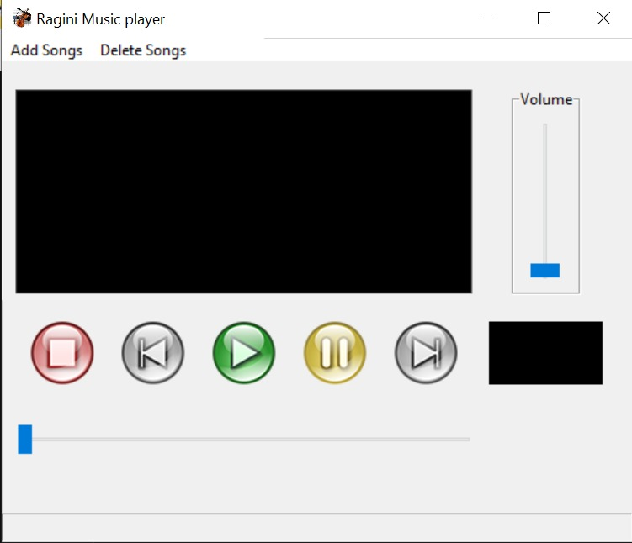

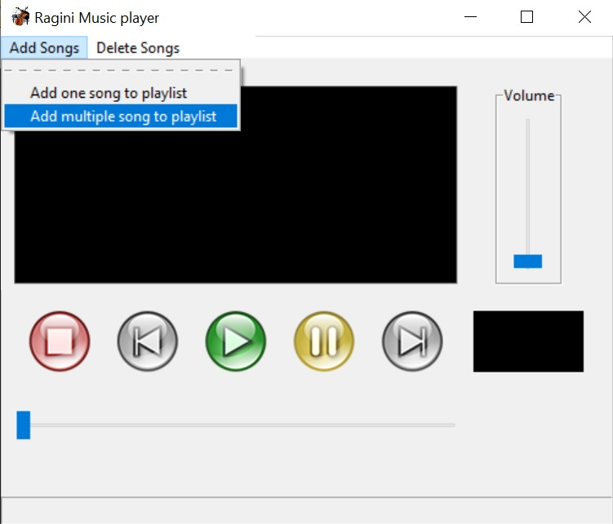

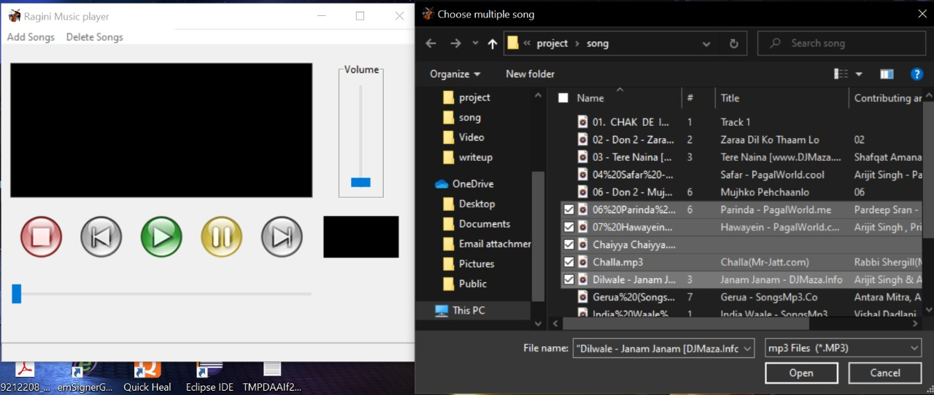

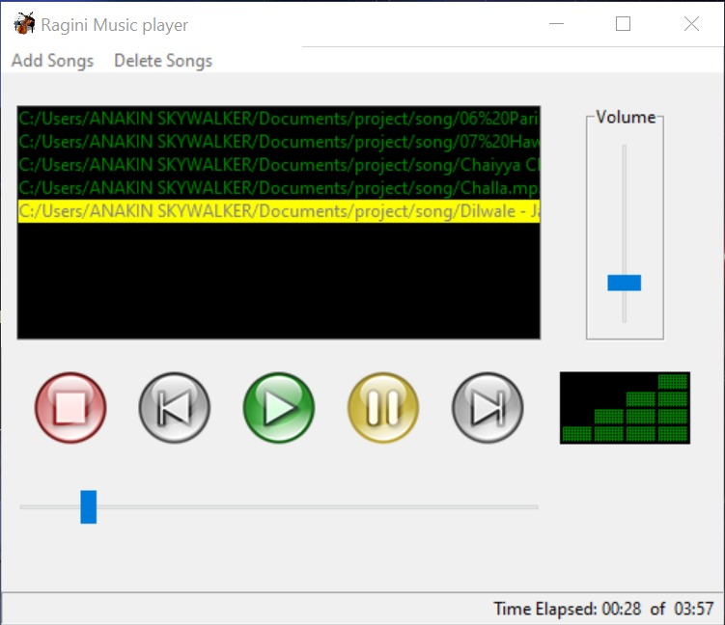

**Conclusion and Future Scope**

MP3 player is a device built to play and listen to digital audio files. These can be either songs or some other audio files. The player was built using Python language. A GUI implementation of the application was developed that is simple and easy to use.

The application provides the user with five options — to add song to a playlist, to play the song, to pause or resume the song, to play the previous song and to play the next song.

The Tkinter library of Python was used to create the GUI of the project. It was used to create the option buttons, the label and the display area.

The Pygame library was used to play the songs, provide pause and resume options, forward or backward the song.

In conclusion, a successful project was built in which songs will play according to the user's preference.

Future scope: This application can be further improved with the help of advanced GUI knowledge, addition of more buttons like shuffle which will make the experience even more user friendly.

**References**

**Acknowledgement**

We have great pleasure in presenting the project report on MUSIC PLAYER USING PYTHON. We take this opportunity to express our sincere thanks towards our guide Guide Merlin Priya Jacob of Computer Engineering, APSIT thane for providing the technical guidelines and suggestions regarding line of work. We would like to express our gratitude towards her constant encouragement, support and guidance through the development of project.

Student Name1: Soumyojyoti Dutta

Student ID1: 19102014

Student Name2: Moksha Shinde

Student ID2: 19102064

Student Name3: Vedang Gore

Student ID4: 19102065